Programming Concept and its planning: Purpose of writing a program
Computer programming is the process of designing and building an executable computer program for accomplishing a specific computing task.
Programming involves tasks such as: analysis, generating algorithms, profiling algorithms' accuracy and resource consumption, and the implementation of algorithms in a chosen programming language (commonly referred to as coding).
The source code of a program is written in one or more languages that are intelligible to programmers, rather than machine code, which is directly executed by the central processing unit. The purpose of programming is to find a sequence of instructions that will automate the performance of a task (which can be as complex as an operating system) on a computer, often for solving a given problem.
The process of programming thus often requires expertise in several different subjects, including knowledge of the application domain, specialized algorithms, and formal logic.
Steps in Program Development
- Problem Definition
- Program Design
- Coding
- Debugging
- Testing
- Documentation
- Maintenance

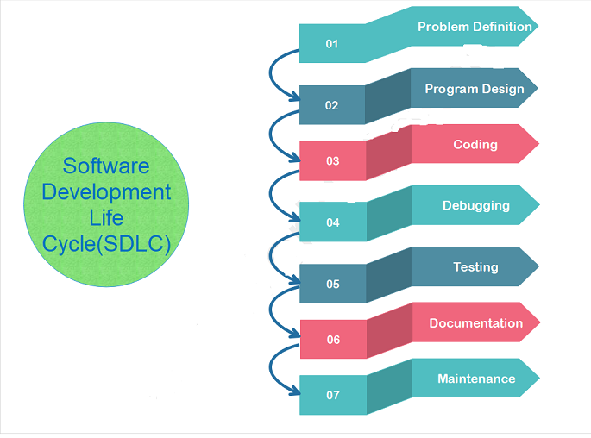

Problem Definition:
- The first step in the process of program development is the thorough understanding and identification of the problem for which is the program or software is to be developed.
- In this step the problem has to be defined formally.
- All the factors like Input/output, processing requirement, memory requirements, error handling, interfacing with other programs have to be taken into consideration in this stage.

Program Design:
- The next stage is the program design. The software developer makes use of tools like algorithms and flowcharts to develop the design of the program.
  - Algorithm
  - Flowchart

Coding:
- Once the design process is complete, the actual computer program is written, i.e. the instructions are written in a computer language.
- Coding is generally a very small part of the entire program development process and also a less time consuming activity in reality.
- In this process all the syntax errors i.e. errors related to spelling, missing commas, undefined labels etc. are eliminated.
- For effective coding some of the guide lines which are applied are :
  - Use of meaningful names and labels of variables,
  - Simple and clear expressions,
  - Modularity with emphasis on making modules generalized,
  - Making use of comments and indenting the code properly,
  - Avoiding jumps in the program to transfer control.

Debugging:
- At this stage the errors in the programs are detected and corrected.
- This stage of program development is an important process. Debugging is also known as program validation.
- Some common errors which might occur in the programs include:
  - Un initialization of variables.
  - Reversing of order of operands.
  - Confusion of numbers and characters.
  - Inverting of conditions eg jumping on zero instead of on not zero.

Testing:
- The program is tested on a number of suitable test cases.
- A test plan of the program has to be done at the stage of the program design itself.
- This ensures a thorough understanding of the specifications.
- The most trivial and the most special cases should be identified and tested.
- It is always useful to include the maximum and minimum values of all variables as test data.

Documentation:
- Documentation is a very essential step in the program development.
- Documentation help the users and the people who maintain the software.
- This ensures that future modification if required can be done easily. Also it is required during redesigning and maintenance.

Maintenance:
- Updating and correction of the program for changed conditions and field experience is accounted for in maintenance.
- Maintenance becomes essential in following situations:
  - Change in specification,
  - Change in equipment,
  - Errors which are found during the actual execution of the program.
A good computer program should have following characteristics:
Portability: Portability refers to the ability of an application to run on different platforms (operating systems) with or without minimal changes.
Readability: The program should be written in such a way that it makes other programmers or users to follow the logic of the program without much effort.
Efficiency: Every program requires certain processing time and memory to process the instructions and data. As the processing power and memory are the most precious resources of a computer, a program should be laid out in such a manner that it utilizes the least amount of memory and processing time.
Structural: To develop a program, the task must be broken down into a number of subtasks. These subtasks are developed independently, and each subtask is able to perform the assigned job without the help of any other subtask. If a program is developed structurally, it becomes more readable, and the testing and documentation process also gets easier.
Flexibility: A program should be flexible enough to handle most of the changes without having to rewrite the entire program. Most of the programs are developed for a certain period and they require modifications from time to time. For example, in case of payroll management, as the time progresses, some employees may leave the company while some others may join. Hence, the payroll application should be flexible enough to incorporate all the changes without having to reconstruct the entire application.
Generality: Apart from flexibility, the program should also be general. Generality means that if a program is developed for a particular task, then it should also be used for all similar tasks of the same domain. For example, if a program is developed for a particular organization, then it should suit all the other similar organizations.
Documentation: Documentation is one of the most important components of an application development. A well-documented application is also useful for other programmers because even in the absence of the author, they can understand it.
Development of an Algorithm, Flow Charts through examples
ALGORITHM:
The word “algorithm” relates to the name of the mathematician Al-khowarizmi, which means a procedure or a technique. Software Engineer commonly uses an algorithm for planning and solving the problems. An algorithm is a sequence of steps to solve a particular problem or algorithm is an ordered set of unambiguous steps that produces a result and terminates in a finite time
Algorithm has the following characteristics
• Input: An algorithm may or may not require input
• Output: Each algorithm is expected to produce at least one result
• Definiteness: Each instruction must be clear and unambiguous.
• Finiteness: If the instructions of an algorithm are executed, the algorithm should terminate after finite number of steps
The algorithm and flowchart include following three types of control structures.
1. Sequence: In the sequence structure, statements are placed one after the other and the execution takes place starting from up to down.
2. Branching (Selection): In branch control, there is a condition and according to a condition, a decision of either TRUE or FALSE is achieved. In the case of TRUE, one of the two branches is explored; but in the case of FALSE condition, the other alternative is taken. Generally, the ‘IF-THEN’ is used to represent branch control.
3. Loop (Repetition): The Loop or Repetition allows a statement(s) to be executed repeatedly based on certain loop condition e.g. WHILE, FOR loops.
Advantages of algorithm
• It is a step-wise representation of a solution to a given problem, which makes it easy to understand.
• An algorithm uses a definite procedure.
• It is not dependent on any programming language, so it is easy to understand for anyone even without programming knowledge.
• Every step in an algorithm has its own logical sequence so it is easy to debug.
HOW TO WRITE ALGORITHMS
Step 1 Define your algorithms input: Many algorithms take in data to be processed, e.g. to calculate the area of rectangle input may be the rectangle height and rectangle width.
Step 2 Define the variables: Algorithm's variables allow you to use it for more than one place. We can define two variables for rectangle height and rectangle width as HEIGHT and WIDTH (or H & W). We should use meaningful variable name e.g. instead of using H & W use HEIGHT and WIDTH as variable name.
Step 3 Outline the algorithm's operations: Use input variable for computation purpose, e.g. to find area of rectangle multiply the HEIGHT and WIDTH variable and store the value in new variable (say) AREA. An algorithm's operations can take the form of multiple steps and even branch, depending on the value of the input variables.
Step 4 Output the results of your algorithm's operations: In case of area of rectangle output will be the value stored in variable AREA. if the input variables described a rectangle with a HEIGHT of 2 and a WIDTH of 3, the algorithm would output the value of 6.
FLOWCHART:
The first design of flowchart goes back to 1945 which was designed by John Von Neumann. Unlike an algorithm, Flowchart uses different symbols to design a solution to a problem. It is another commonly used programming tool. By looking at a Flowchart one can understand the operations and sequence of operations performed in a system. Flowchart is often considered as a blueprint of a design used for solving a specific problem.
Advantages of flowchart:
• Flowchart is an excellent way of communicating the logic of a program.
• Easy and efficient to analyze problem using flowchart.
• During program development cycle, the flowchart plays the role of a blueprint, which makes program development process easier.
• After successful development of a program, it needs continuous timely maintenance during the course of its operation. The flowchart makes program or system maintenance easier.
• It is easy to convert the flowchart into any programming language code.
Flowchart is diagrammatic /Graphical representation of sequence of steps to solve a problem. To draw a flowchart following standard symbols are use
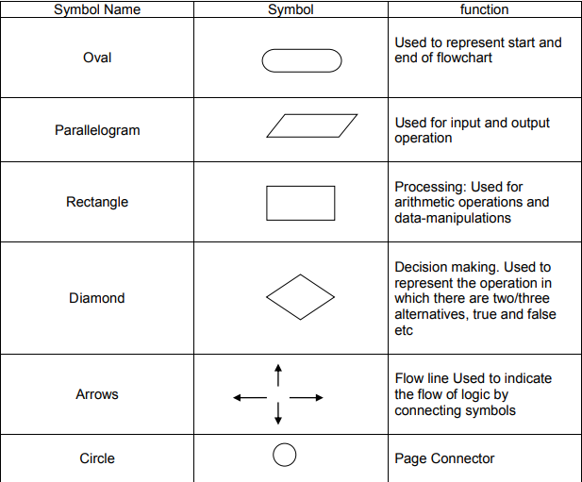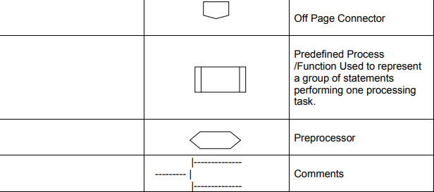

The language used to write algorithm is simple and similar to day-to-day life language. The variable names are used to store the values. The value store in variable can change in the solution steps. In addition some special symbols are used as below
Assignment Symbol ( ← or =) is used to assign value to the variable.e.g. to assign value 5 to the variable HEIGHT, statement is
HEIGHT 5
or
HEIGHT = 5
The symbol ‘=’ is used in most of the programming language as an assignment symbol, the same has been used in all the algorithms and flowcharts in the manual.
The statement C = A + B means that add the value stored in variable A and variable B then assign/store the value in variable C.
The statement R = R + 1 means that add I to the value stored in variable R and then assign/store the new value in variable R, in other words increase the value of variable R by 1.

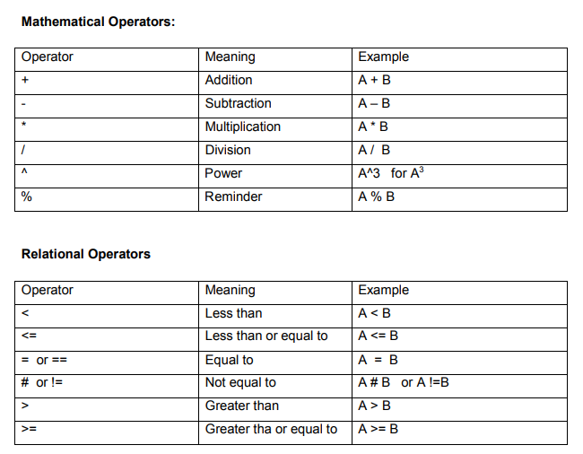
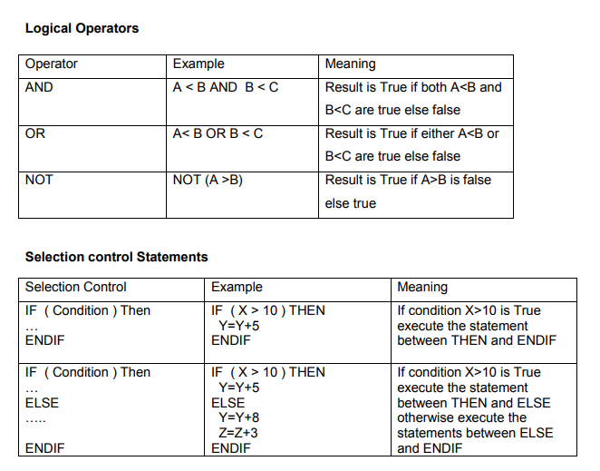
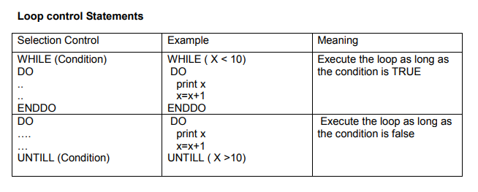
GO TO statement also called unconditional transfer of control statement is used to transfer control of execution to another step/statement. . e.g. the statement GOTO n will transfer control to step/statement n.
Note: We can use keyword INPUT or READ or GET to accept input(s) /value(s) and keywords PRINT or WRITE or DISPLAY to output the result(s).

Algorithm & Flowchart to find the sum of two numbers

Algorithm
Step-1 Start
Step-2 Input first numbers say A
Step-3 Input second number say B
Step-4 SUM = A + B
Step-5 Display SUM
Step-6 Stop

OR

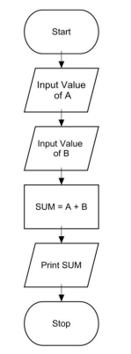

Algorithm
Step-1 Start
Step-2 Input two numbers say A & B
Step-3 SUM = A + B
Step-4 Display SUM
Step-5 Stop

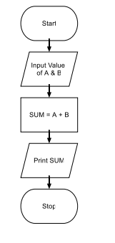

Algorithm & Flowchart to convert temperature from Celsius to Fahrenheit
C : temperature in Celsius
F : temperature Fahrenheit
Algorithm
Step-1 Start
Step-2 Input temperature in Celsius say C Step-3 F = (9.0/5.0 x C) + 32
Step-4 Display Temperature in Fahrenheit F
Step-5 Stop

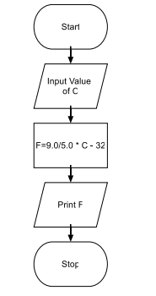
PROGRAMMING LANGUAGES: History, Classifications
Programming languages are basically classified into two main categories – Low level language and High level language. However, there also exists another category known as Middle level language. Every programming language belongs to one of these category and sub-category.
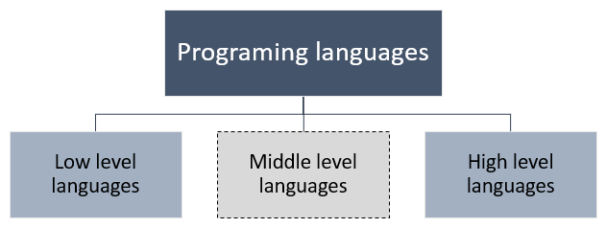 Classification of programming languages
Machine level languages (First Generation of programming language):

It’s the lowest level and named as first generation of programming language. Machine level language consist only two condition i.e. either true (1) or false (0); this type of language known as binary language. A computer system could understand only binary language i.e. all the instruction feed into the computer system must be in the form of 0 or 1. Machine level languages are very tough to understand by the humans.
Advantages of machine level language:
- There have many advantage of machine level language; some of them are listed below;
- Machine level languages are directly interacting with computer system.
- There is no requirement of software of conversion like compiler or interpreters.
- It takes very less time to execute a program, because there is no conversion take place.
Disadvantages of machine language:
- Its machine dependent language i.e. individual program required for each machine.
- To develop a program in machine language, it’s too hard to understand and program.
- Its time consuming to develop new programs.
- Debugging process is very hard because of finding errors process is typical.
- Machine language is not portable language.
Assembly level languages (Second Generation programming language):
It’s a middle level and named as second generation programming language. It contains the same instruction as machine level language, but the instructions and the variables have specific name or called commands instead of being just binary numbers. It also uses symbols to describe field of instructions. Every aspect of machine variable in program, assembly language uses one statement per machine instruction. It managed explicitly all instruction like register allocation, call, stack, timer, jump, loop etc.

To understand the assembly language computer must require an assembler which takes a part in between assembly language and computer system to convert the assembly instructions into the machine language. This assembler is software or a set of program which translates assemble language programming instruction into the machine language. For example;

LOAD BASEPAY

ADD OVERPAY

STORE GROSSPAY

Advantages of Assembly language:
There have many advantage of assembly level language; some of them are listed below;

- It is easily understood by human because it is uses statements instead of binary digits.
- To develop a program it takes less time.
- Debugging and troubleshoot is easy due to easily find error.
- It’s a portable language.
Disadvantages of Assembly language:
- It’s a machine dependent language due to that program design for one machine no use of other machine.
- Sometime it’s hard to understand the statement or command use.
High-level language (Third Generation):
High level language is the upper level language and also known as third generation programming language. It does consider as high level because, which language comes under this category are closer to human languages. Hence this is highly understood programming language by human. There have many examples of high level languages such as, FORTRAN, Pascal, C, C++, JAVA, ADA, COBOL, LISP, Prolog etc.

The first high level programming language was written in 1950s. Those programs written in high level language must require software or a set of program to translate that program into machine understandable. This software called compiler and/or interpreter. The main job of compiler and translator is to take the source code of the program and convert that code into the machine understood code.
4GL
A fourth generation (programming) language (4GL) is a grouping of programming languages that attempt to get closer than 3GLs to human language, form of thinking and conceptualization.
4GLs are designed to reduce the overall time, effort and cost of software development. The main domains and families of 4GLs are: database queries, report generators, data manipulation, analysis and reporting, screen painters and generators, GUI creators, mathematical optimization, web development and general purpose languages.
Also known as a 4th generation language, a domain specific language, or a high productivity language.
4GLs are more programmer-friendly and enhance programming efficiency with usage of English-like words and phrases, and when appropriate, the use of icons, graphical interfaces and symbolical representations. The key to the realization of efficiency with 4GLs lies in an appropriate match between the tool and the application domain.

Advantages of Programming language
- Programming languages are programmer friendly. They are easy to write, debug and maintain.
- It provide higher level of abstraction from machine languages.
- It is machine independent language.
- Easy to learn.
- Less error prone, easy to find and debug errors.
- High level programming results in better programming productivity.

Disadvantages of High level language
- It takes additional translation times to translate the source to machine code.
- High level programs are comparatively slower than low level programs.
- Compared to low level programs, they are generally less memory efficient.
- Cannot communicate directly with the hardware.

TYPES OF SOFTWARE:
Software is a set of programs that governs the functioning of a computer.
System Software
System software is a collection of one or more programs used to control and coordinate the hardware and other application software. Generally the system software may perform the following functions:
Communicates with hardware devices. Controls and monitors the proper use of various hardware resources like CPU, memory, peripheral devices like monitor, printer etc.Supports the execution and development of other application software.
Few examples of system software are:
- Operating system
- Programming language translators
- Communication software
- Compiler and Interpreters
- Command line shell
Application Software
Application software is a collection of one or more programs used to solve a specific task.

Generally software used in banking industry, airline/railway reservation, generation of telephone or electricity bills etc. all fall under application software.
Few examples of application software are:
- Word processing software
- Spreadsheet software
- Database software
- Education software
- Entertainment software
Utility Software
Utility software is a collection of one or more programs that helps the user in system maintenance tasks and in performing tasks of routine nature. Utility programs help the users in disk formatting, data compression, data backup, scanning for viruses etc.

Few examples of utility software are:
- Anti-virus
- Registry cleaners
- Disk defragmenters
- Data backup utility
- Disk cleaners

Translators
The most general term for a software code converting tool is “translator.” A translator, in software programming terms, is a generic term that could refer to a compiler, assembler, or interpreter; anything that converts higher level code into another high-level code (e.g., Basic, C++, Fortran, Java) or lower-level (i.e., a language that the processor can understand), such as assembly language or machine code.
Compilers
Compilers convert high-level language code to machine (object) code in one session. Compilers can take a while, because they have to translate high-level code to lower-level machine language all at once and then save the executable object code to memory. A compiler creates machine code that runs on a processor with a specific Instruction Set Architecture (ISA), which is processor-dependent.
Interpreters
Another way to get code to run on your processor is to use an interpreter, which is not the same as a compiler. An interpreter translates code like a compiler but reads the code and immediately executes on that code, and therefore is initially faster than a compiler. Thus, interpreters are often used in software development tools as debugging tools, as they can execute a single in of code at a time. Compilers translate code all at once and the processor then executes upon the machine language that the compiler produced.
Assemblers
An assembler translates a program written in assembly language into machine language and is effectively a compiler for the assembly language, but can also be used interactively like an interpreter. Assembly language is a low-level programming language. Low-level programming languages are less like human language in that they are more difficult to understand at a glance; you have to study assembly code carefully in order to follow the intent of execution and in most cases, assembly code has many more lines of code to represent the same functions being executed as a higher-level language. An assembler converts assembly language code into machine code (also known as object code), an even lower-level language that the processor can directly understand.
LINKER
A linker is a computer program that takes one or more object files generated by a compiler and combines them into one, executable program.

Computer programs are usually made up of multiple modules that span separate object files, each being a compiled computer program. The program as a whole refers to these separately compiled object files using symbols. The linker combines these separate files into a single, unified program.
LIBRARIES.
A library is a collection of non-volatile resources used by computer programs, often for software development. These may include configuration data, documentation, help data, message templates, pre-written code and subroutines, classes, values or type specifications. Library code is organized in such a way that it can be used by multiple programs that have no connection to each other, while code that is part of a program is organized to be used only within that one program.

Packaged software
Packaged software, also called a software package, is software that is often used together, performs similar functions, or includes similar features, and is bundled together as a set of software programs.
One of the most prominent examples is something like the Microsoft Office package, which includes individual applications such as Word, Excel, Access and PowerPoint.
Corel -> (a). Corel photos, (b). Corel Paint, (c). Corel Draw, etc
Tailored software
Custom software (also known as bespoke software or tailor-made software) is software that is specially developed for some specific organization or other user.
So, Software that is made for an individual or business that performs tasks specific to their needs is called custom software. For example, if you had a home business, you may hire someone to create a custom software program to help print and view invoices.
The numerous advantages of custom software development include integration, personalization, and cost effectiveness. It's better to create tailor-made products than to go off-the-shelf.
Management Information Systems (MIS) Software:
Management Information Systems (MIS) is the study of people, technology, organizations, and the relationships among them. MIS professionals help firms realize maximum benefit from investment in personnel, equipment, and business processes. MIS is a people-oriented field with an emphasis on service through technology.
MULTIMEDIA SOFTWARE
A multimedia program, multimedia application, or any multimedia software is software that is capable of playing or recording audio files or playing or recording video files.
Any visual representation that has a combination of audio, video, animation, or graphics. Multimedia is usually a more enjoyable and informative experience than text.
Software used in multimedia
- Music Sequencing and Notation.
- Digital Audio.
- Graphics and Image Editing.
- Video Editing.
- Animation.
- DirectX
- Rendering Tools.
- Multimedia Authoring.
Graphics software
Graphics software creates, edits, and manages two-dimensional images. These computer graphics may be clip art, web graphics, logos, headings, backgrounds, digital photos, or other kinds of digital images. There are the unconventional uses as well, such as editing video in Photoshop or 3D drawing in Illustrator.
Applications:
Common graphics editors include Photoshop, Illustrator, Paint Shop Pro, CorelDRAW,
Accounting software
Accounting software is a type of computer software used by accounting professionals to manage accounts and perform accounting operations.

Accounting is the systematic practice, work or process of communicating and recording financial information. In a business setting, this is done for the purposes of internal and external audits, required reports and financial analysis to meet legal or internal managerial requirements. Accounting may also include systematic and diverse measurement, classification, verification, summation and interpretation of financial information.

Accounting software can range from simple, single-entry programs used for individual record-keeping to more sophisticated, double-entry systems that can process accounts receivable, accounts payable, payroll and inventory, among other functions.

Statistical software
Statistical software are programs which are used for the statistical analysis of the collection, organization, analysis, interpretation and presentation of data.
The goal of statistical analysis is to identify trends. A retail business, for example, might use statistical analysis to find patterns in unstructured and semi-structured customer data that can be used to create a more positive customer experience and increase sales.
After collecting data you can analyze it to:
- Summarize the data. For example, make a pie chart.
- Find key measures of location. ...
- Calculate measures of spread: these tell you if your data is tightly clustered or more spread out. ...
- Make future predictions based on past behavior. ...
- Test an experiment's hypothesis.

